- Newsletter  March 2023  In this month’s issue:  Blood drive record!  Michael Schultz ordained as Deacon  Good Samaritan  Polar Plunge – brrrr!  Happy Birthdays!  Our newest member | Knights of Columbus  Fr. Roy Dentinger Council #390  St. Patrick Catholic Church, 1000 N. Beckley Station Road, Louisvillle, Ky 40245  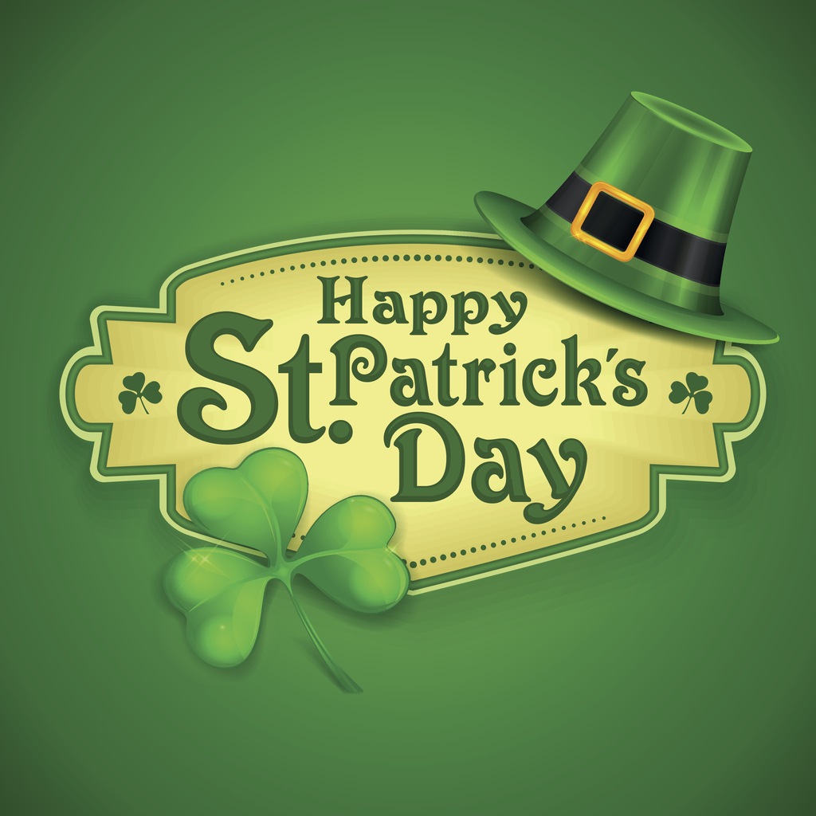  Share a pint with friends and family – Erin Go Bragh!  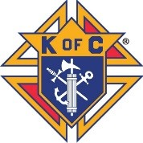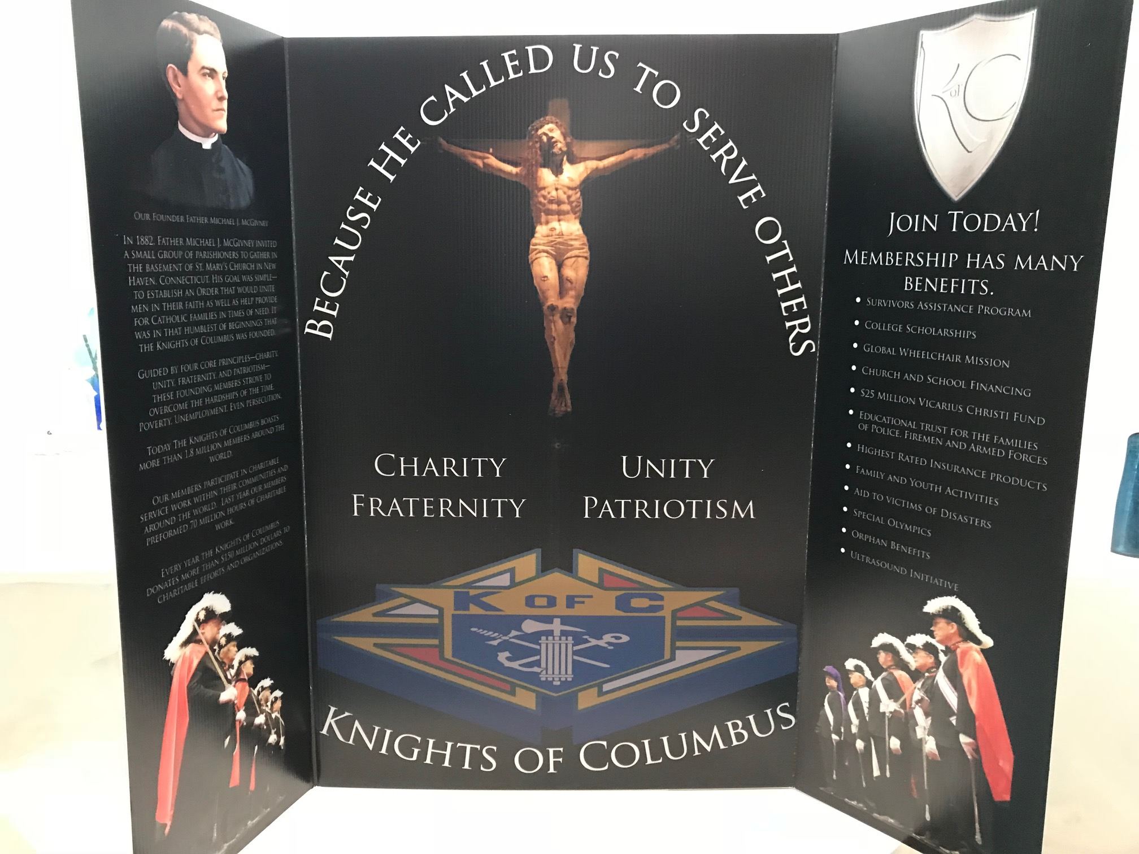  Our Council, Fr. Roy Dentinger, was formed in October of 2015 and named for a past State Chaplain of the Knights. We have grown from 30+ members to 125 strong as of this month. We support over 30 charitable organizations and activities through our four Faith in Action pillars: Faith, Family, Community and Life.  We meet every 3rd Thursday of the month at 7 pm in the Miles Meeting room at St. Patrick Catholic Church.
- Your Officers  Dave Cuda  Grand Knight  Luke Rebholz  Deputy Grand Knight  Chaplain  Fr. Jeff Shooner  Chancellor  Mark Crush  Recorder  Bob Lescinski  Financial Secretary  Kevin Chesser Sr.  Treasurer  Joe Wagner  Advocate  Don Schuler  Warden  Wayne Burd  Inside Guard  Kirk Diegel  Outside Guard  Jeff McMahon  Lecturer  Dwight Frank  Trustees  Joe Gates  Mike Connelly  Paul Tadatada  Your Program  Directors  ______________  Program Director  Paul Tadatada  Faith Director  Leo Hobbs  Family Director  Joe Gates  Community Director  Val Henson  Life Director  Bob Singleton  Membership Director  Rocco Pigneri  Retention Chairman  Kevin Chesser Sr.  Insurance Promotion  Dwight Frank  Vocation Chairman  Leo Hobbs  Public Relations  Paul Tadatada  Upcoming in  March  ___________  Every Tuesday  40 Days for Life prayers  March 11  St. Patrick’s Day parade  March 16  Council meeting  March 16  Ky. Celebration of Life  Banquet  March 18 - 19  Membership drive weekend  March 18  St. Patrick Celtic Ceilidh  March 25  Soup kitchen at the  Cathedral  March 25-26  Rosary weekend – pray  For Faith  March 29  Stations of the Cross  Schuler | Knights Blood Drive sets new record  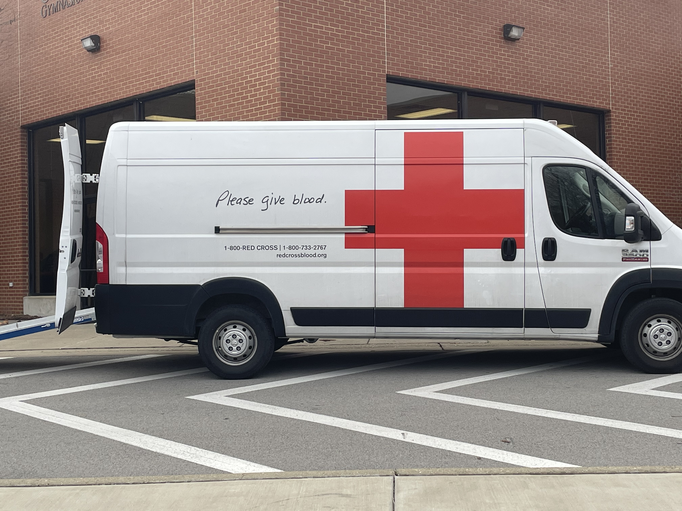  The Knights blood drive on February 12 set a new record for number of donations…..71! We would like to congratulate Wayne Burd, all the volunteers, and most of all…anyone who donated, for making this the most successful drive in our history. Dennis Beatty would be proud!  Michael Schultz ordained as Deacon  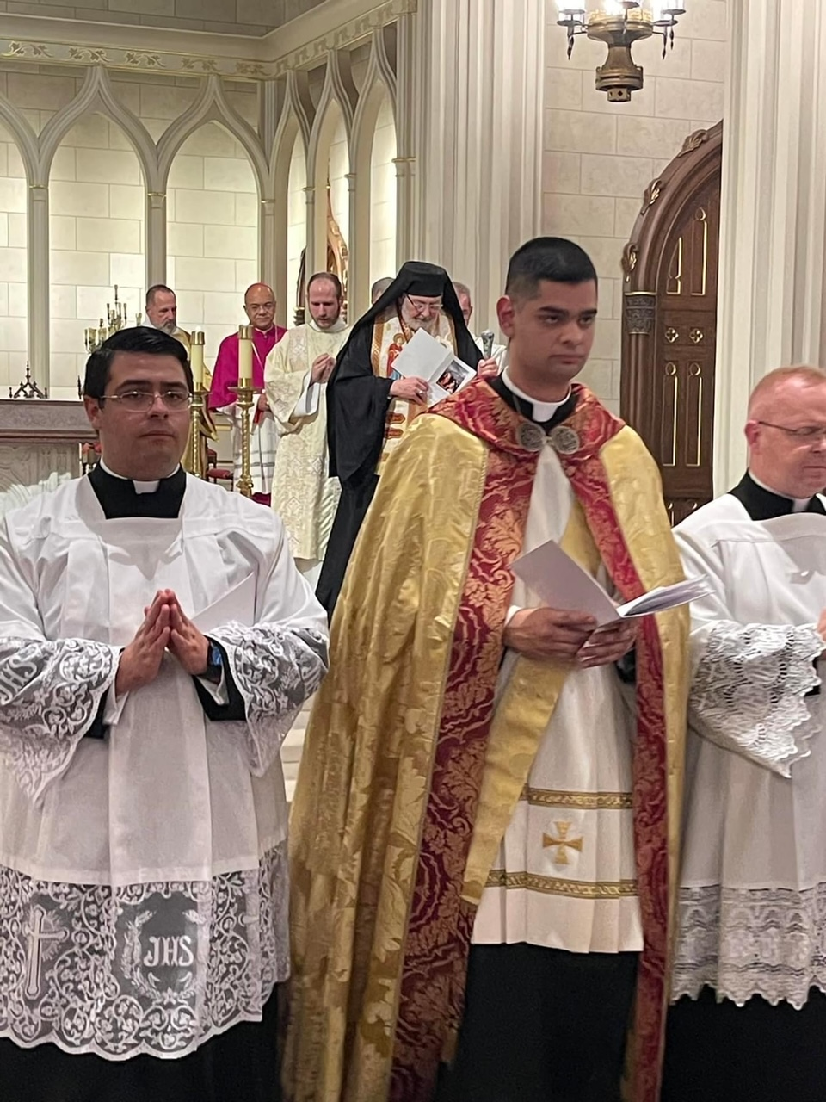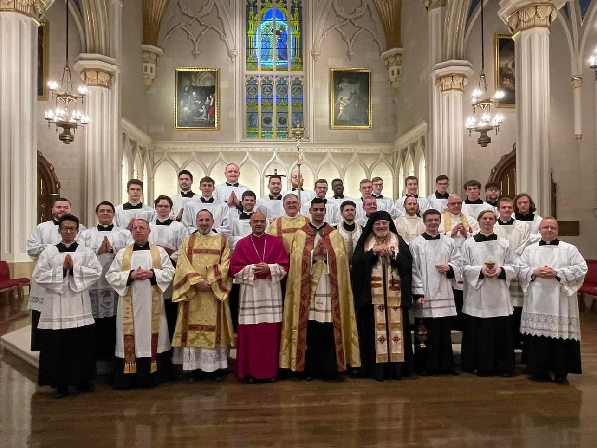  Michael Schultz was ordained as deacon at the Cathedral of the Assumption on February 18. The ordination was co-officiated by Archbishop Shelton Fabre and by Romanian Catholic Bishop John Michael Botean of the Canton, Ohio diocese. Please pray for Michael as he continues on his journey toward the priesthood.  Brother Knight shows what it means to be Good Samaritan  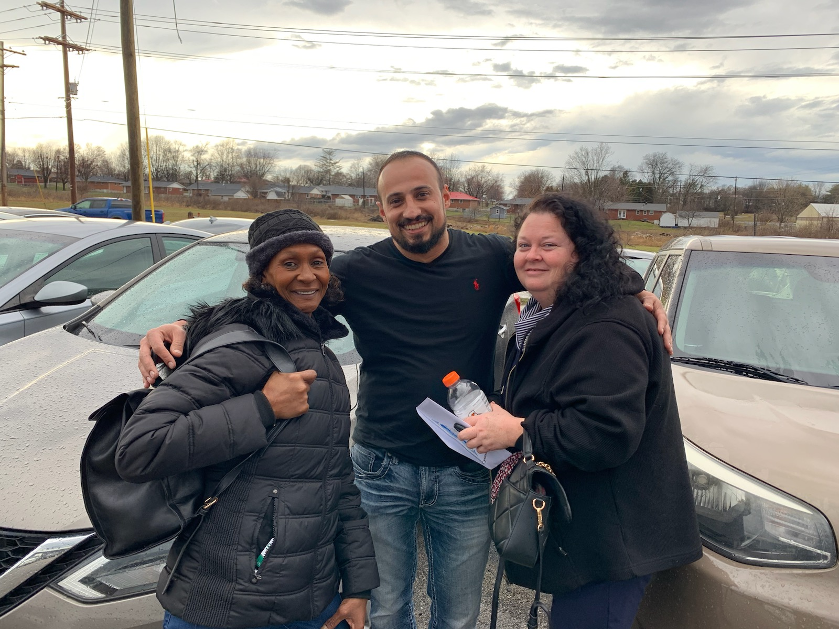  Brother Mike LaFramboise met Melissa (pictured on the left) a security guard at St. Martin of Tours Catholic church. Melissa’s car, a Kia with 160,000 miles, would no longer run and repairs were going to be too expensive. Melissa was in tears, alone against the world, and having a hard time getting by. She was depending on friends or public transportation to get her to work. Brother Mike felt the call of the Holy Spirit…he solicited donations and assistance from fellow bible study members and was able to get a new car purchased for her. Brother Mike embodies the true spirit of the Good Samaritan.  Polar Plunge taken to raise money for Special Olympics  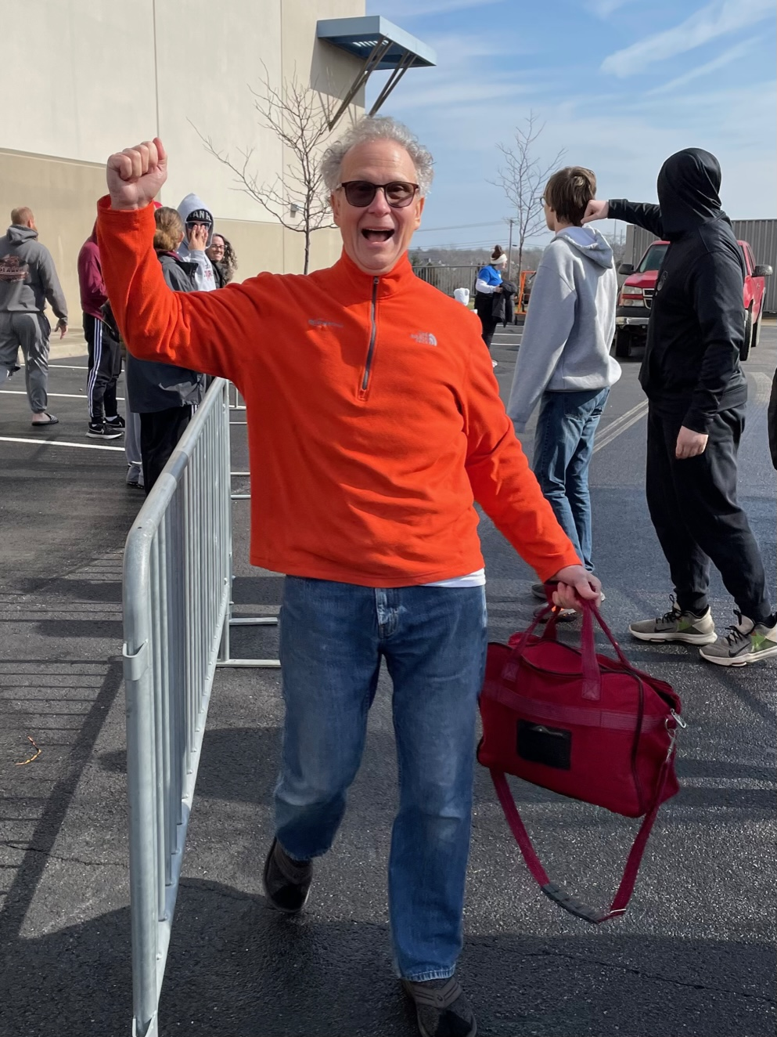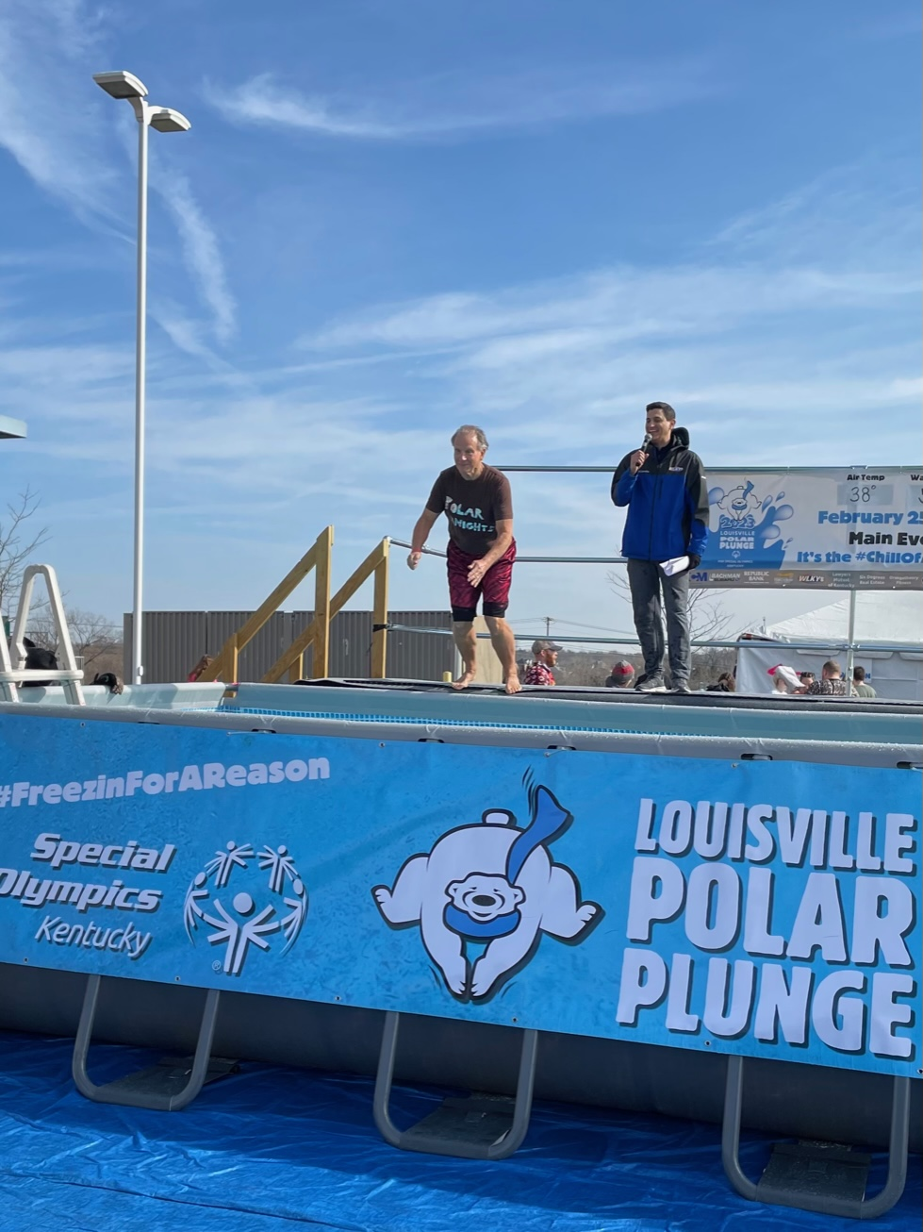  Brother Bob Lescinski took the plunge this year to raise money for Special Olympics. He was able to raise $1379 for the cause.  Well done Brother…we hope you have thawed out by now!  Happy March Birthdays!  Birthday wishes go out to the following Brother Knights:  Brian O'Dea 4th  Rev. Jeffrey Shooner 7th  Frank Otte 14th  William L Ray Jr 14th  Todd Fortwengler 15th  Jeremy McCool 15th  Rev. Robert Osborne 20th *95*  Gerald Nauert 25th  Meet our newest member  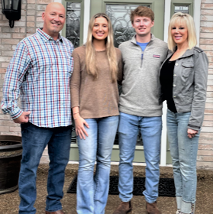  Hello Brother Knights! My name is Mike Schnurr. My wife Terri, son Nathan and daughter Anna are super excited to move back to Louisville. The past 7 years we lived in Lexington where I became a 1st degree Knight at Mary Queen of the Holy Rosary church. We were very active with the church and at Lexington Catholic High School. I look forward to meeting and working with this council at St Patrick’s! Thank you and God Bless

