- Newsletter  May - June 2023  In this month’s issue:  New officers elected!  Blood drive results  Successful fundraiser for Special Olympics  Little Way baby bottle  Campaign begins  Men’s Club golf scramble  KofC State Convention  Memorial Weekend Mass  Miles Meeting room  Décor updated | Knights of Columbus  Fr. Roy Dentinger Council #390  St. Patrick Catholic Church, 1000 N. Beckley Station Road, Louisvillle, Ky 40245  Summer is here! Enjoy your vacations!  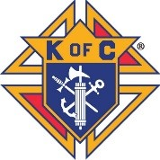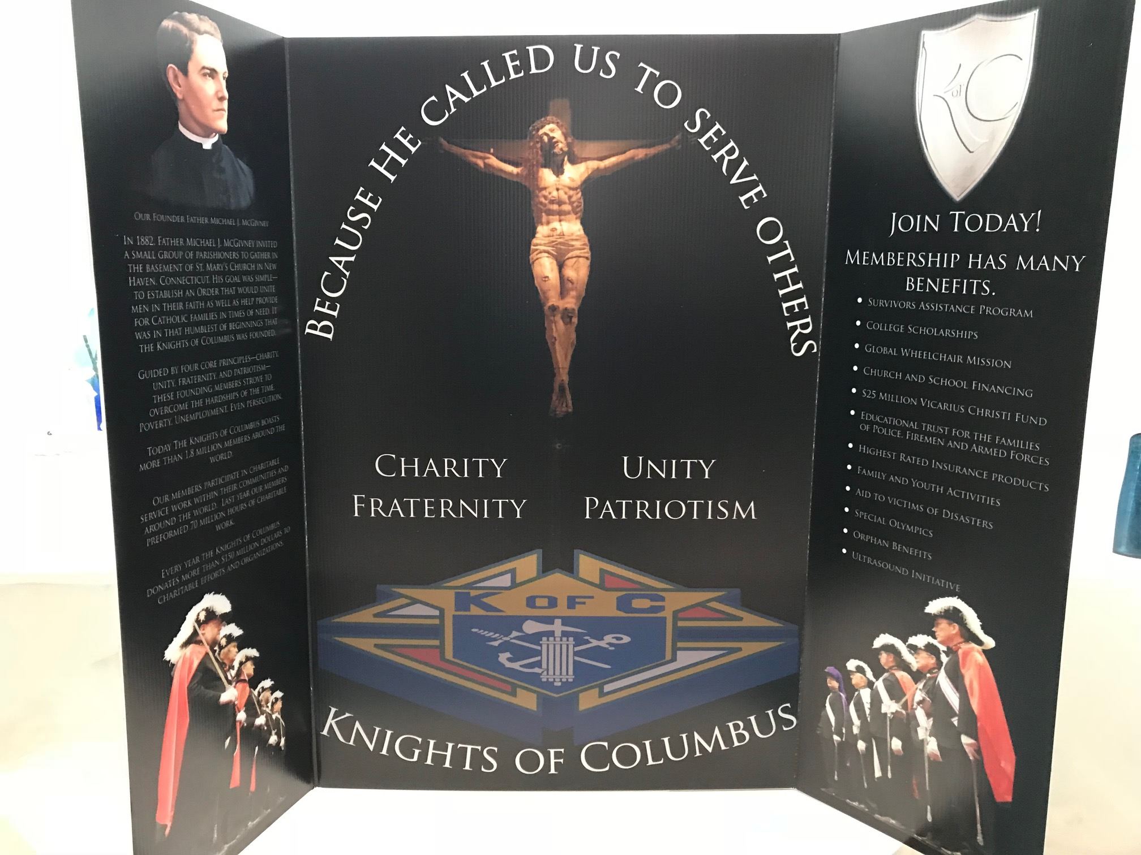  Our Council, Fr. Roy Dentinger, was formed in October of 2015 and named for a past State Chaplain of the Knights. We have grown from 30+ members to 127 strong as of this month. We support over 30 charitable organizations and activities through our four Faith in Action pillars: Faith, Family, Community and Life.  We meet every 3rd Thursday of the month at 7 pm in the Miles Meeting room at St. Patrick Catholic Church.
- Your Officers  Dave Cuda  Grand Knight  Luke Rebholz  Deputy Grand Knight  Chaplain  Fr. Jeff Shooner  Chancellor  Mark Crush  Recorder  Bob Lescinski  Financial Secretary  Kevin Chesser Sr.  Treasurer  Joe Wagner  Advocate  Don Schuler  Warden  Wayne Burd  Inside Guard  Kirk Diegel  Outside Guard  Jeff McMahon  Lecturer  Dwight Frank  Trustees  Joe Gates  Mike Connelly  Paul Tadatada  Your Program  Directors  ______________  Program Director  Paul Tadatada  Faith Director  Leo Hobbs  Family Director  Joe Gates  Community Director  Val Henson  Life Director  Bob Singleton  Membership Director  Rocco Pigneri  Retention Chairman  Kevin Chesser Sr.  Insurance Promotion  Dwight Frank  Vocation Chairman  Leo Hobbs  Public Relations  Paul Tadatada  Upcoming in  June  ___________  June 11  Blood drive  June 11  Corpus Christi procession  June 15  Council meeting  June 17  Let’s Dance Louisville  June 17-18  Collect Little Way bottles  June 24  Soup kitchen at the  Cathedral  June 24  Officers installation and  Family dinner at rectory  June 24-25  SVDP Food drive  June 27  Fraternal benefits seminar  Schuler | New officers elected!!!  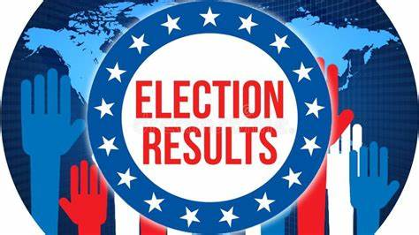  At our May meeting, we voted for new council officers for the fraternal year 2023-24…and the winners are:  Grand Knight – Dave Cuda  Deputy Grand Knight – Wayne Burd  Chancellor – Mark Crush  Recorder – Bob Lescinski  Treasurer – Joe Wagner  Advocate – John Wernert  Warden – Dominique Bouvet  Inside Guard – Steve Zagar  Outside Guard – Mark Huntebrinker  3 year Trustee – Kevin Chesser Sr.  2 year Trustee – Paul Tadatada  1 year Trustee – Mike Connelly  Installation of officers will take place following the 5 pm Mass on Saturday, June 24. There will be a dinner afterwards, at the rectory, for Knights and their families to celebrate our new leadership. Fried chicken and drinks will be provided. A sign up is going out encouraging attendees to bring a side or dessert.  Blood Drives still going strong  Our April blood drive had 69 units donated…another strong showing but just short of our record of 71 in February. We host a blood drive every other month. Please donate the gift of life if you can!  Kentucky Special Olympics Salute to Summer Games  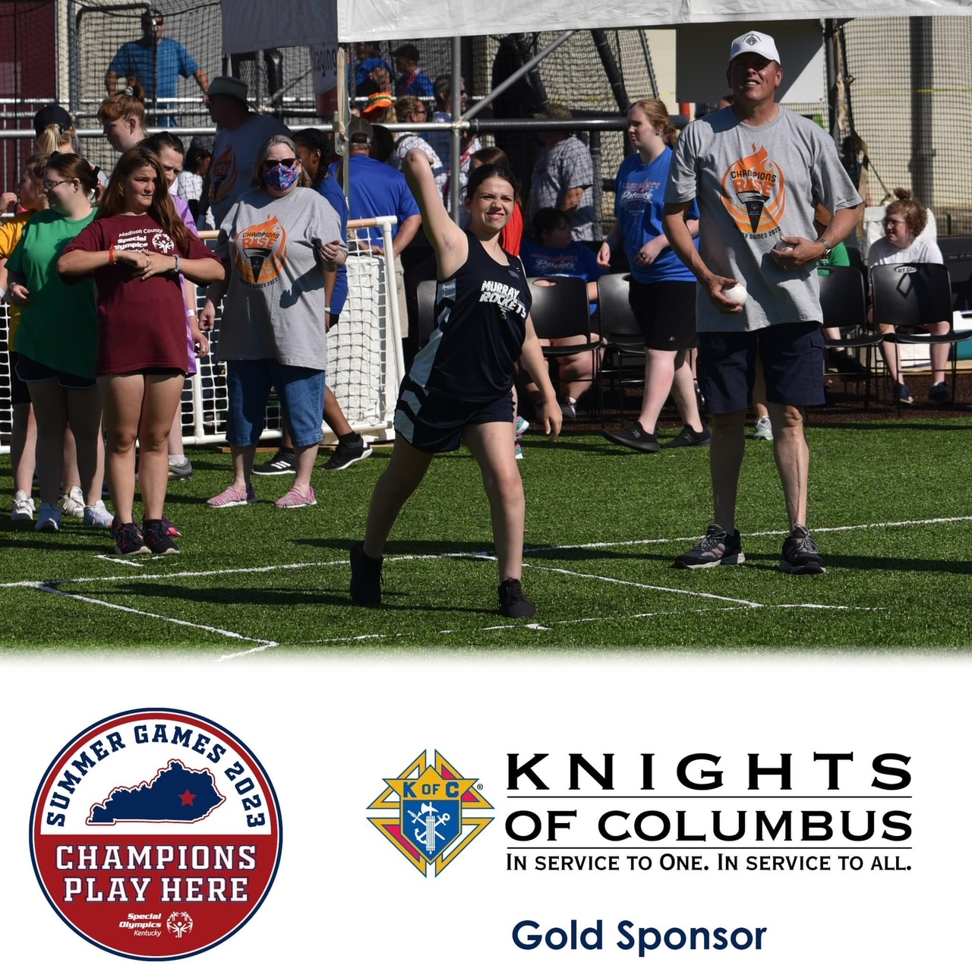  The Kentucky State Knights of Columbus set a goal to raise $12,000 for the Summer Games this year…with a total of $12,435 actually raised! Our council was responsible for raising a new record amount of $2068 for the cause, about 1/6 of the state total! Everyone at Kentucky Special Olympics wants to thank us for our outstanding support and achievement in helping keep the games alive in our state!  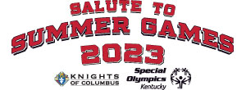  Little Way Baby Bottle Boomerang Underway  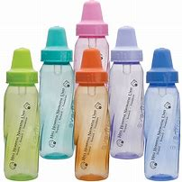  The baby bottle boomerang to raise money for the Little Way Pregnancy Center kicked off on Mother’s Day. Donors should fill their bottles with change and bills and return to St. Patrick’s at Masses on Father’s Day weekend, June 17-18.  Men’s Club hold successful scramble  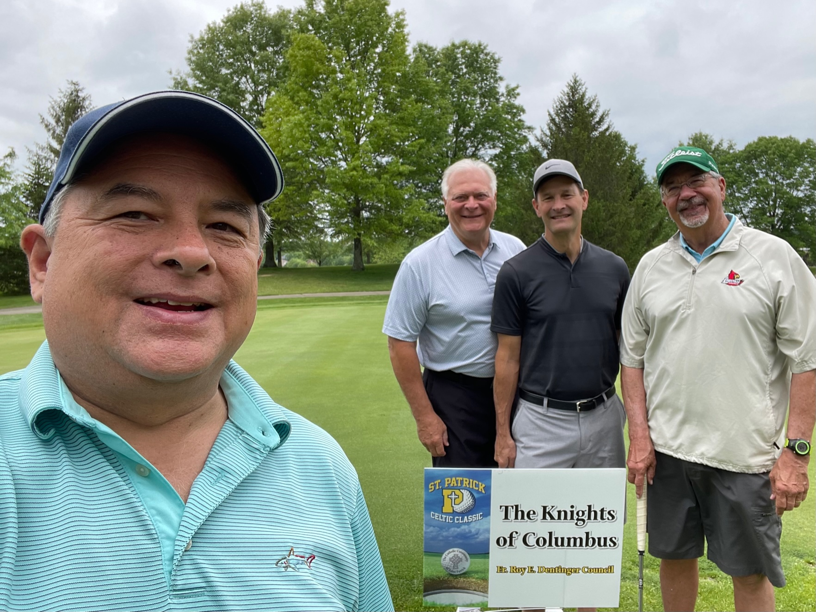  The Knights sponsored a hole and participated in the St. Patrick’s Men’s Club Celtic scramble at the Polo Fields in May. Proceeds from the scramble were to benefit the St. Mary’s Center. A record number of teams participated this year!  KofC State Convention held in Frankfort  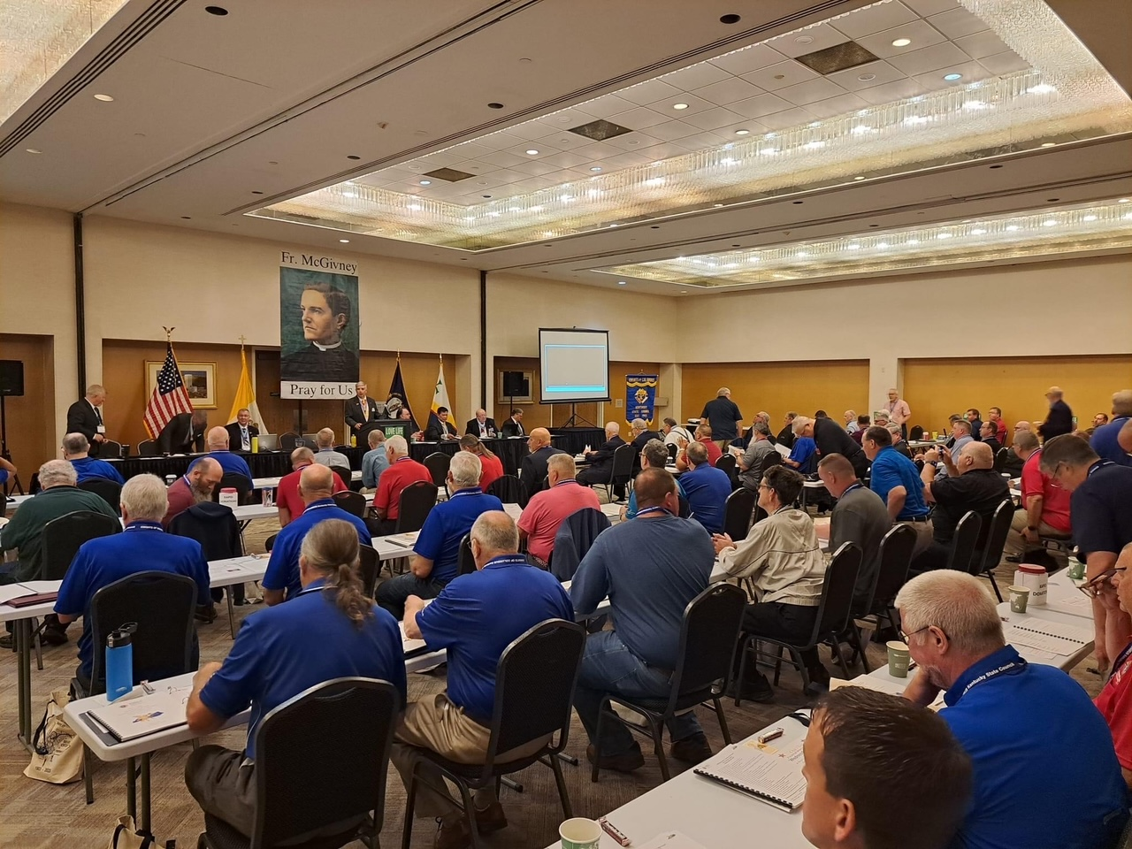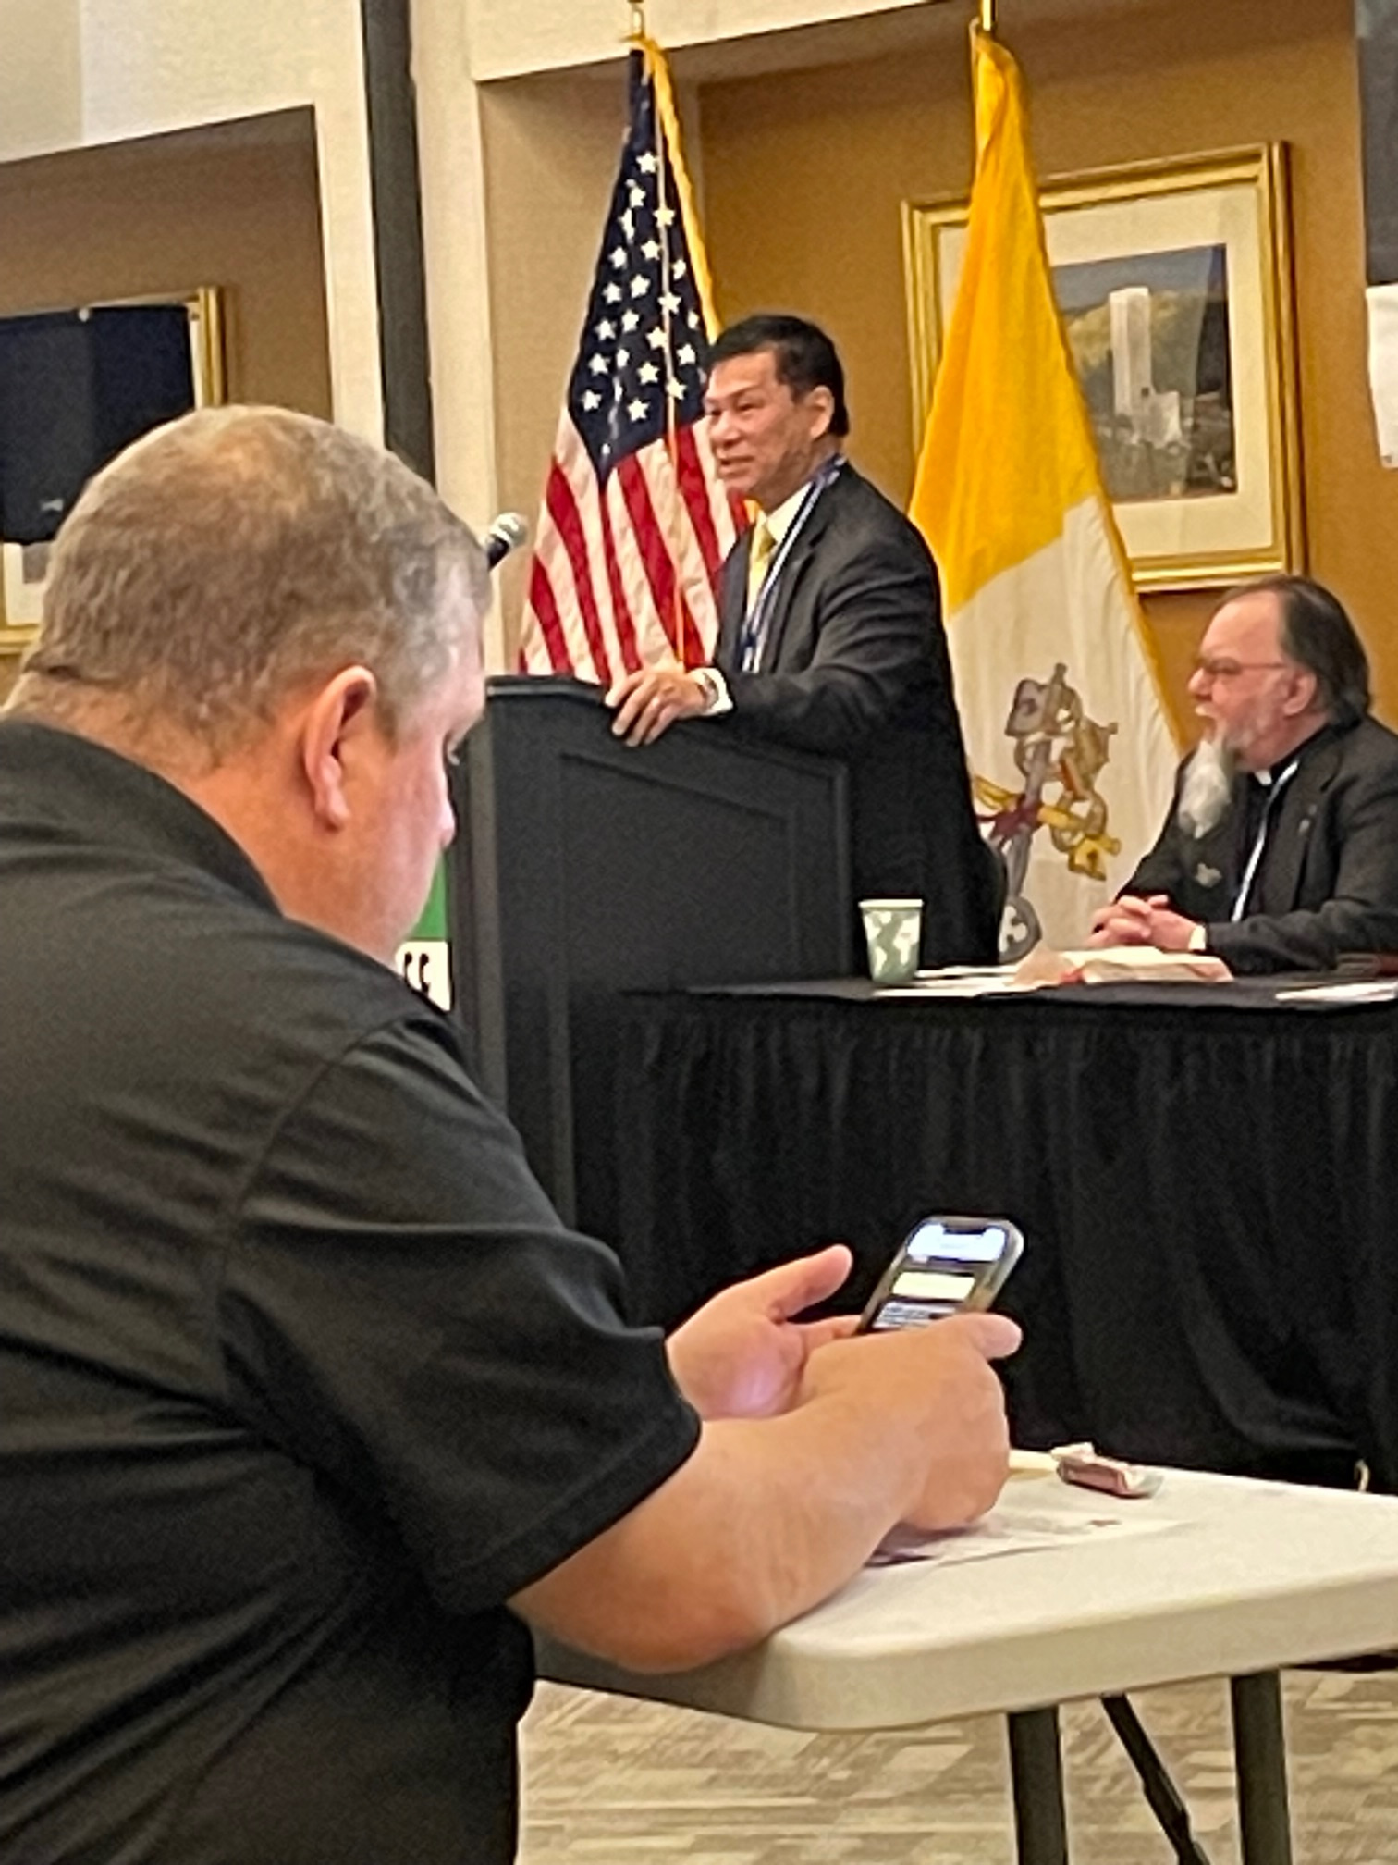  The annual State Convention was held in May with keynote speaker, Supreme Director Antonio Pascua. He highlighted positive things happening in our order but also warned that only 34% of Catholics are attending Mass once per month, and only 17% attend weekly. This weakens our pool of prospective members. Supreme Knight Patrick Kelly sent remarks via video and stressed the following items to be worked on this coming year:  - We need to strengthen Catholic men – initiating Cor meetings in 5 provinces now.  - We need to strengthen Catholic families, both spiritually and financially.  - We must re-commit to being the strong right arm of the church – support the National Eucharistic Revival.  - Further expand witness to charity – through ASAP and other programs.  - We must work on membership growth – seek out Catholic men who need our fellowship.  Memorial Weekend Mass  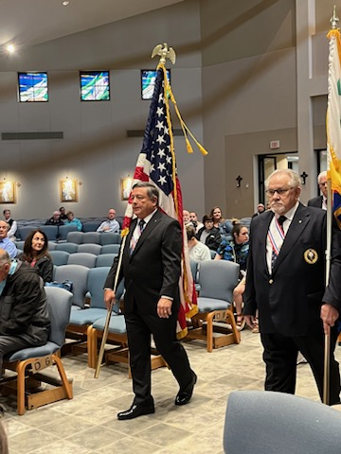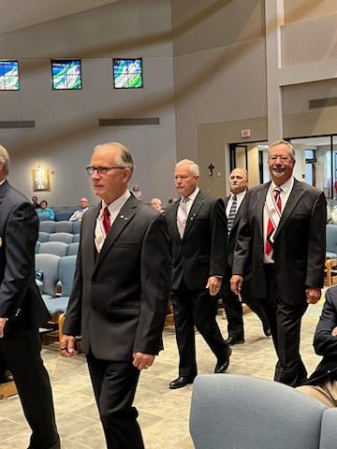  The Knights, led by the Archangel Assembly, processed into Memorial weekend Mass at 8:30 on Sunday morning at St. Patrick. They did so at the 11:00 Mass at St. Michael as well. Our 4th Degree (the Patriotic Degree) do so, to salute, and help remember those men and women who have fallen while serving our nation.  Check out the new decor  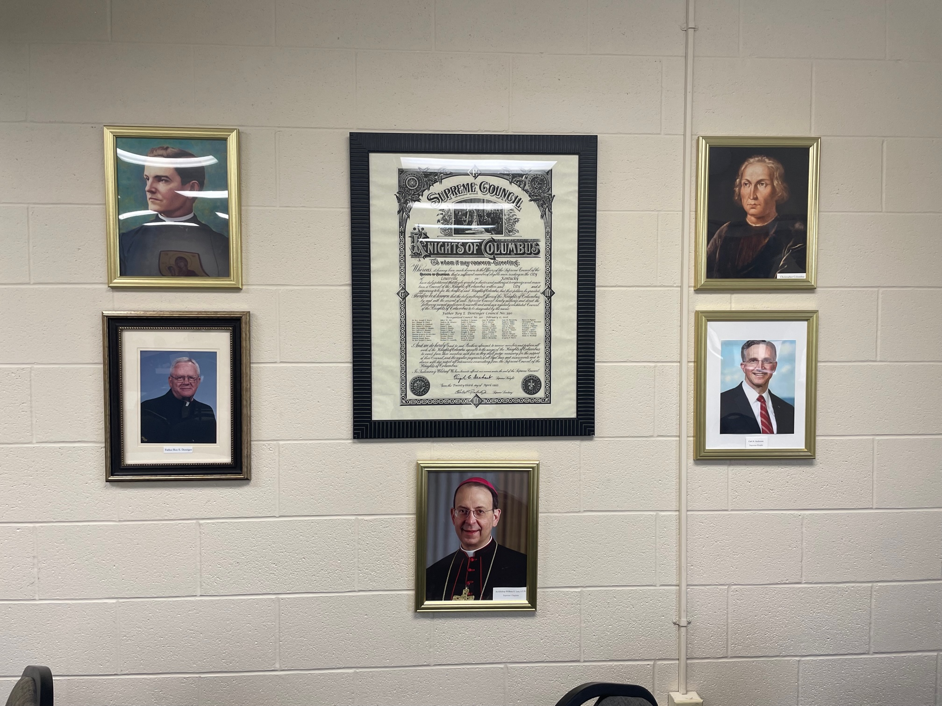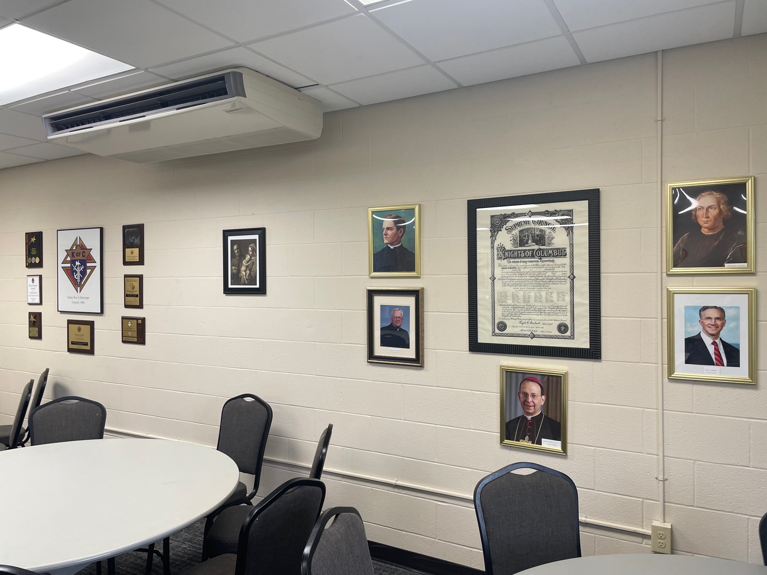  Our décor is now proudly displayed in the Miles Meeting room for all to see. All meetings held in that room will know that St. Patrick has a strong and vibrant council! Thanks to Dave Naber and his maintenance staff for getting this done.

