- Newsletter  January 2023  In this month’s issue:  Star Council Award  Blood drive has large turnout  Christmas Party at the rectory  Refugees welcomed  Soup kitchen serves during frigid weather  Happy Birthday! | Knights of Columbus  Fr. Roy Dentinger Council #390  St. Patrick Catholic Church, 1000 N. Beckley Station Road, Louisvillle, Ky 40245    New Year’s blessings to you and your families!  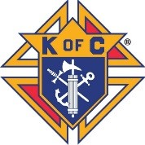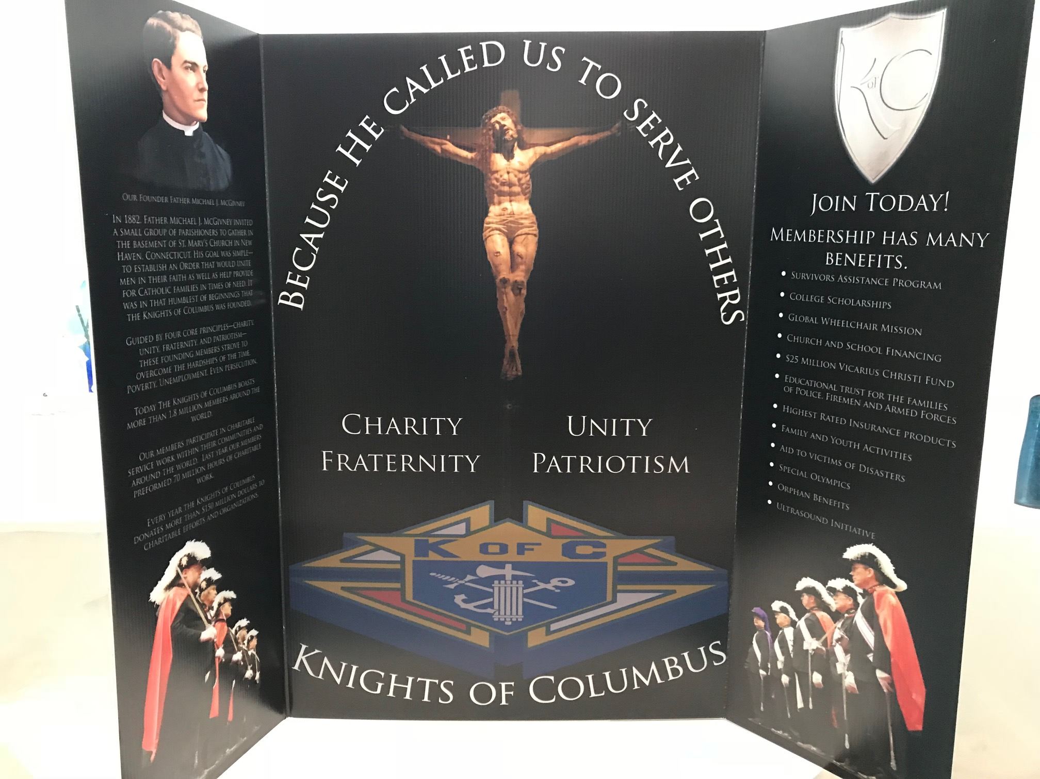  Our Council, Fr. Roy Dentinger, was formed in October of 2015 and named for a past State Chaplain of the Knights. We have grown from 30+ members to 124 strong as of this month. We support over 30 charitable organizations and activities through our four Faith in Action pillars: Faith, Family, Community and Life.  We meet every 3rd Thursday of the month at 7 pm in the Miles Meeting room at St. Patrick Catholic Church.
- Your Officers  Dave Cuda  Grand Knight  Luke Rebholz  Deputy Grand Knight  Chaplain  Fr. Jeff Shooner  Chancellor  Mark Crush  Recorder  Bob Lescinski  Financial Secretary  Kevin Chesser Sr.  Treasurer  Joe Wagner  Advocate  Don Schuler  Warden  Wayne Burd  Inside Guard  Kirk Diegel  Outside Guard  Jeff McMahon  Lecturer  Dwight Frank  Trustees  Joe Gates  Mike Connelly  Paul Tadatada  Your Program  Directors  ______________  Program Director  Paul Tadatada  Faith Director  Leo Hobbs  Family Director  Joe Gates  Community Director  Val Henson  Life Director  Bob Singleton  Membership Director  Rocco Pigneri  Retention Chairman  Kevin Chesser Sr.  Insurance Promotion  Dwight Frank  Vocation Chairman  Leo Hobbs  Public Relations  Paul Tadatada  Upcoming in  January  ___________  January 6, 13 & 20  CSAA Intramural Basketball  January 14  Pro-Life Mass  January 15  Clergy Appreciation Dinner  January 17  Alcohol Awareness training  To serve liquor  January 19  Council meeting  January 19-27  Novena for Life  January 28  Soup kitchen at the  Cathedral  January 28  Men’s Club Trivia Night  January 28-29  Rosary weekend – pray  For Life  Schuler | Star Council Award received for sixth straight year  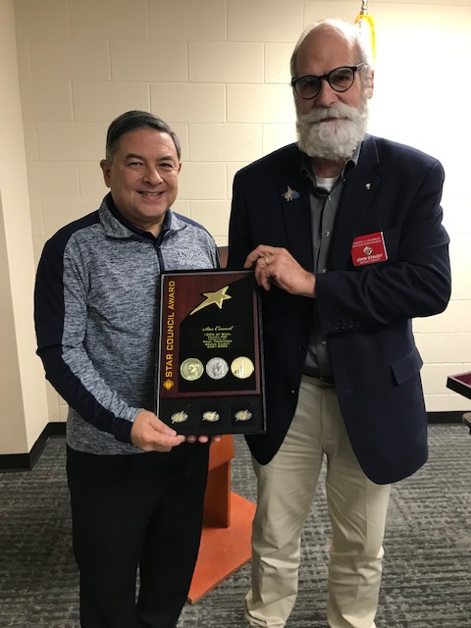  Our council has received the Star Council award from Supreme for the 2021-22 fraternal year. The award was presented by District Deputy John Staudt at our December meeting. We could never achieve this without the time, talent and treasure contributed by all of our most worthy members!  December blood drive is a huge success  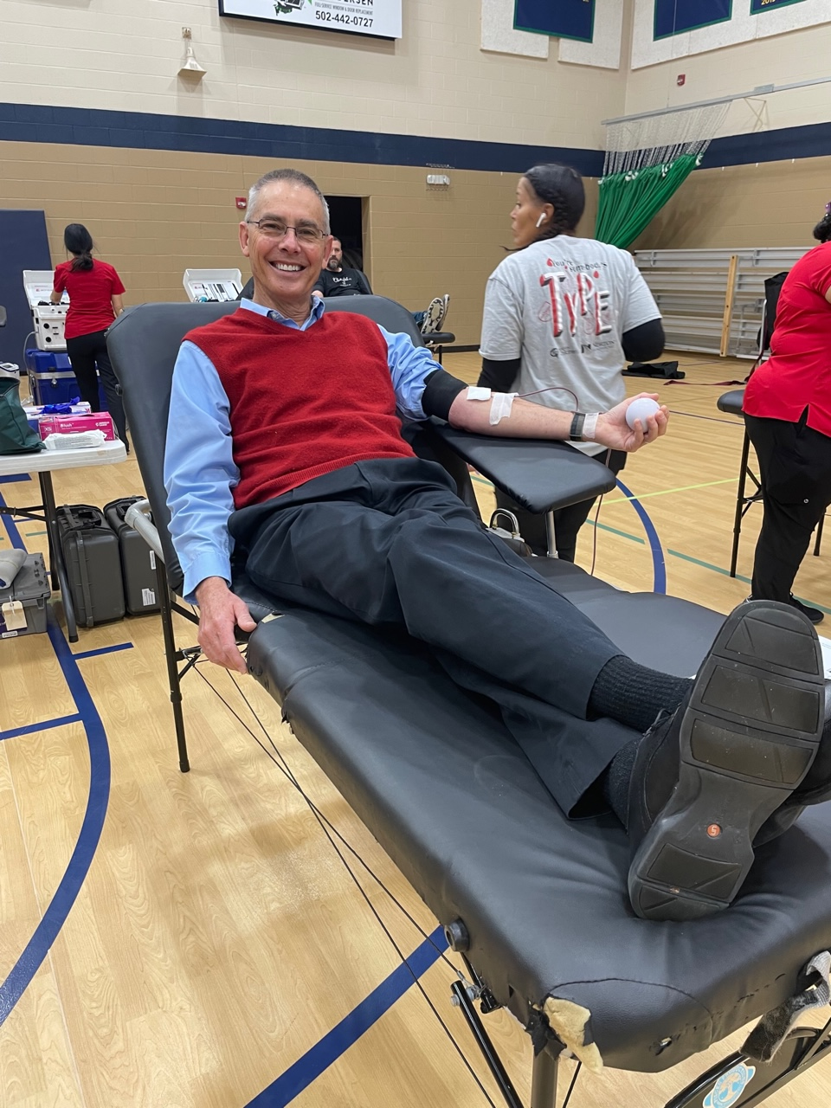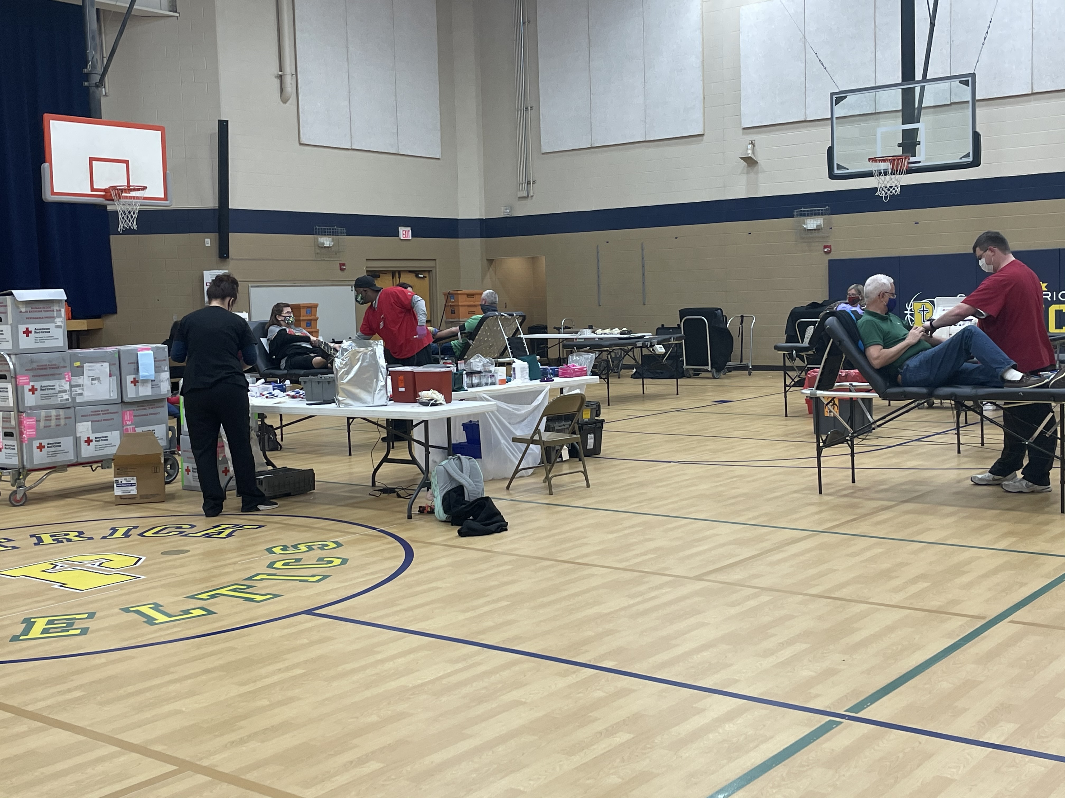  The blood drive collected 67 units of blood, just missing our donation record by one unit. Several Knights donated blood, as well as volunteering that day. Please plan on giving blood at our next drive in February.  Knights celebrate Christmas at the rectory  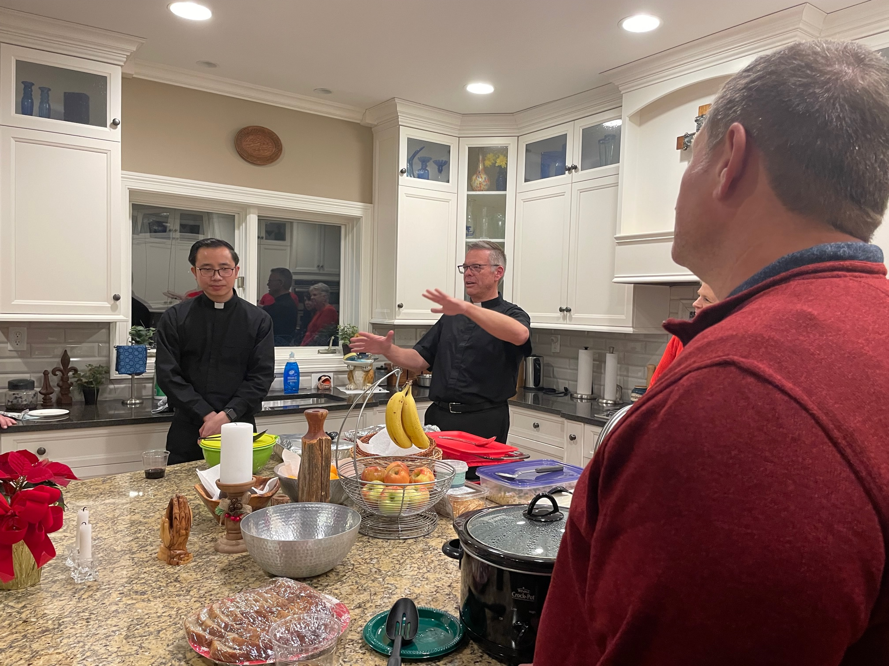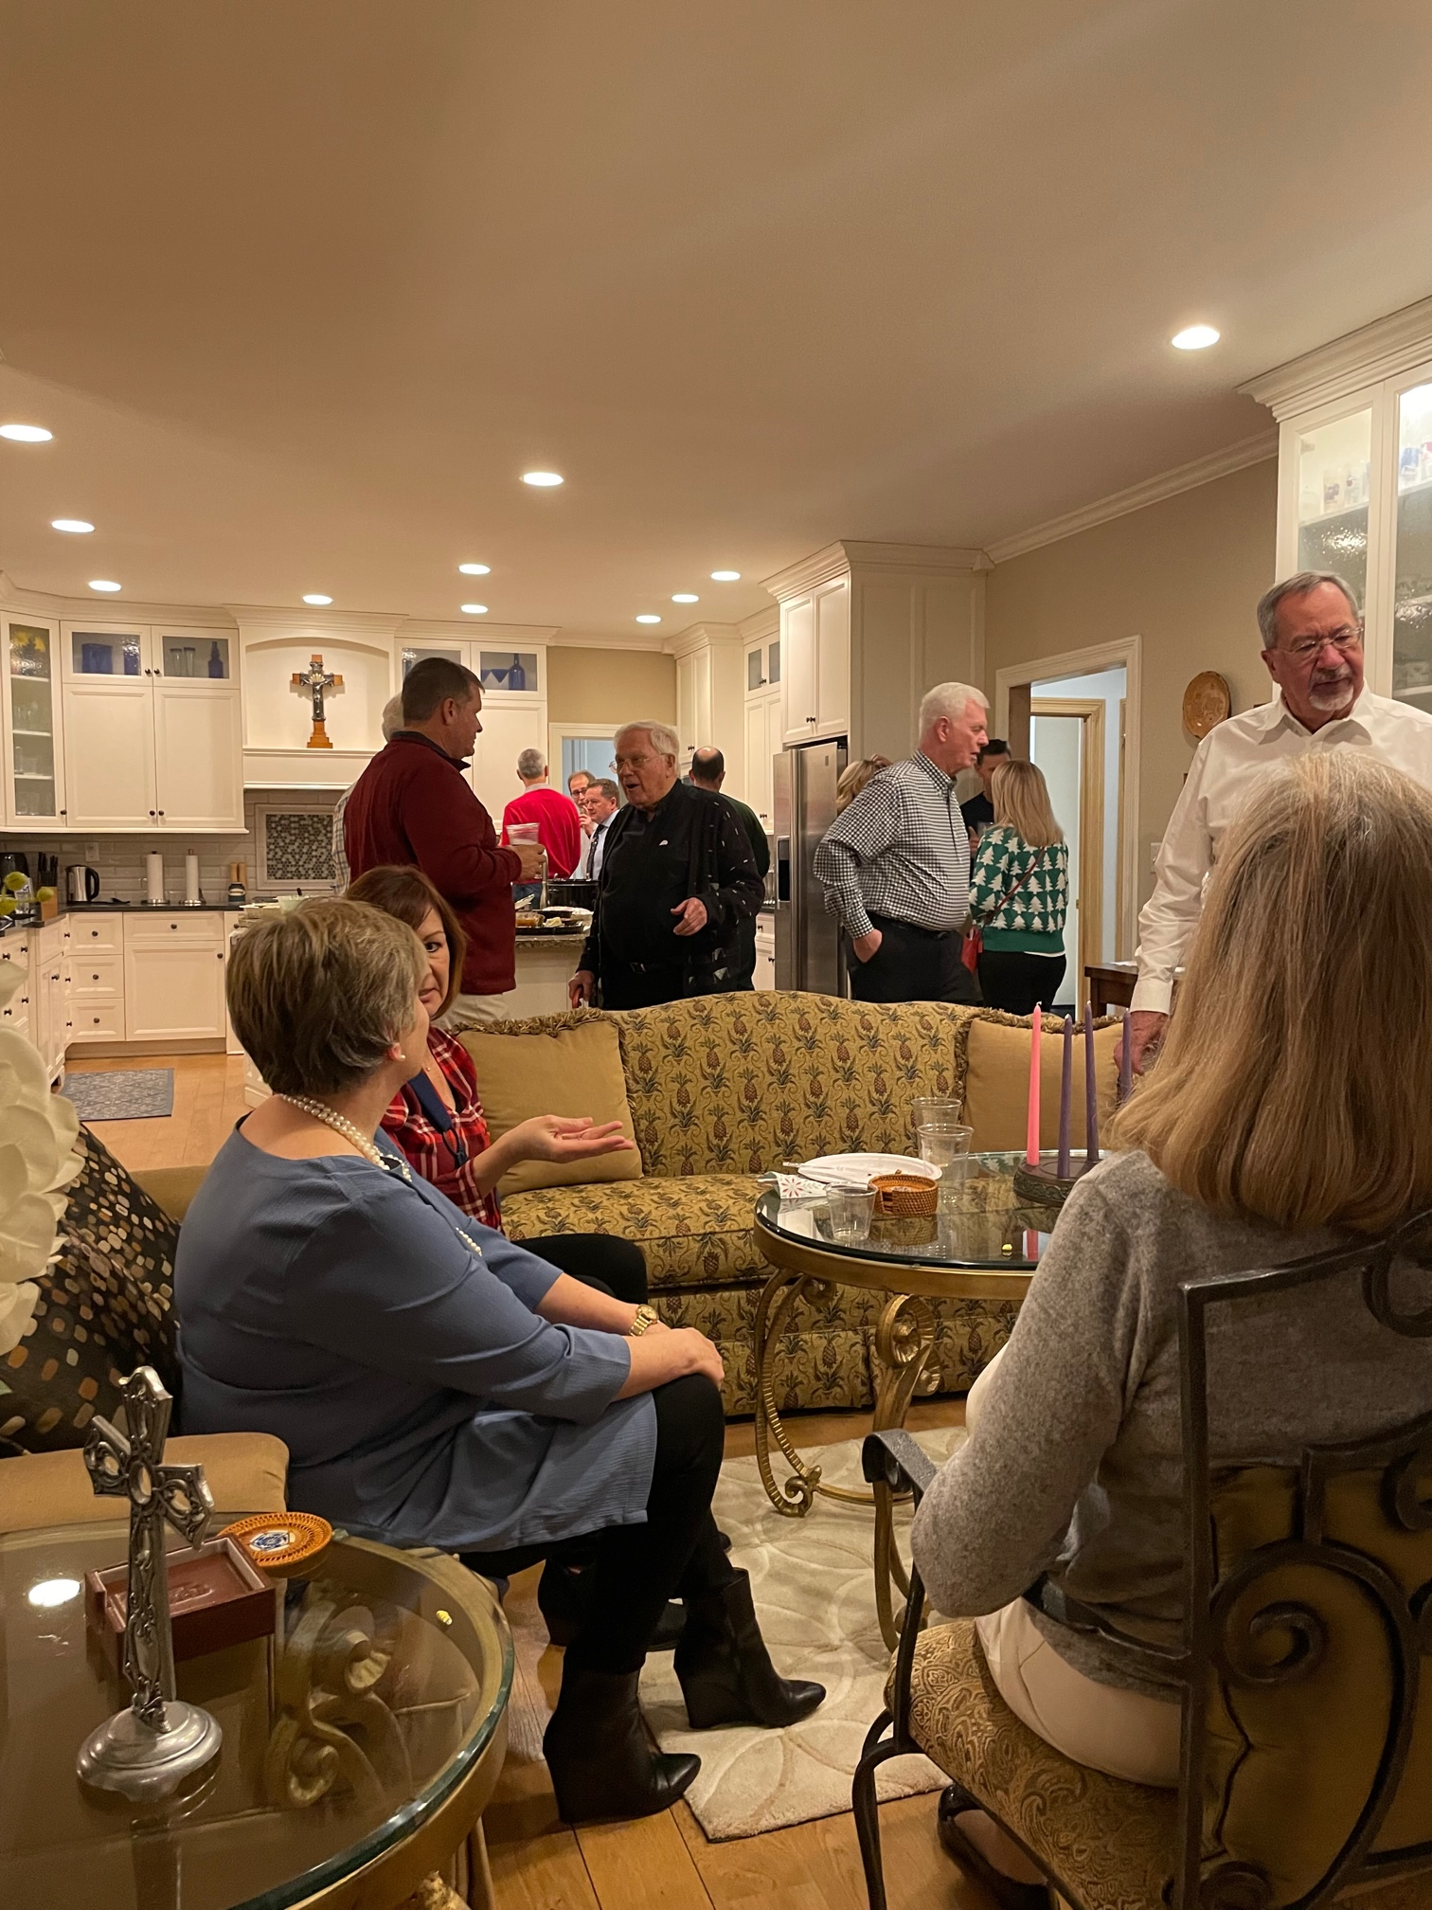  The Knights had our annual Christmas party at the rectory in early December. In attendance were Fr. Jeff, Fr. Quan, Fr. Tony and Fr. Oz, as well as over 40 Knights and their wives. The feast and fellowship was capped off with a bourbon tasting featuring Monk’s Road bourbon.  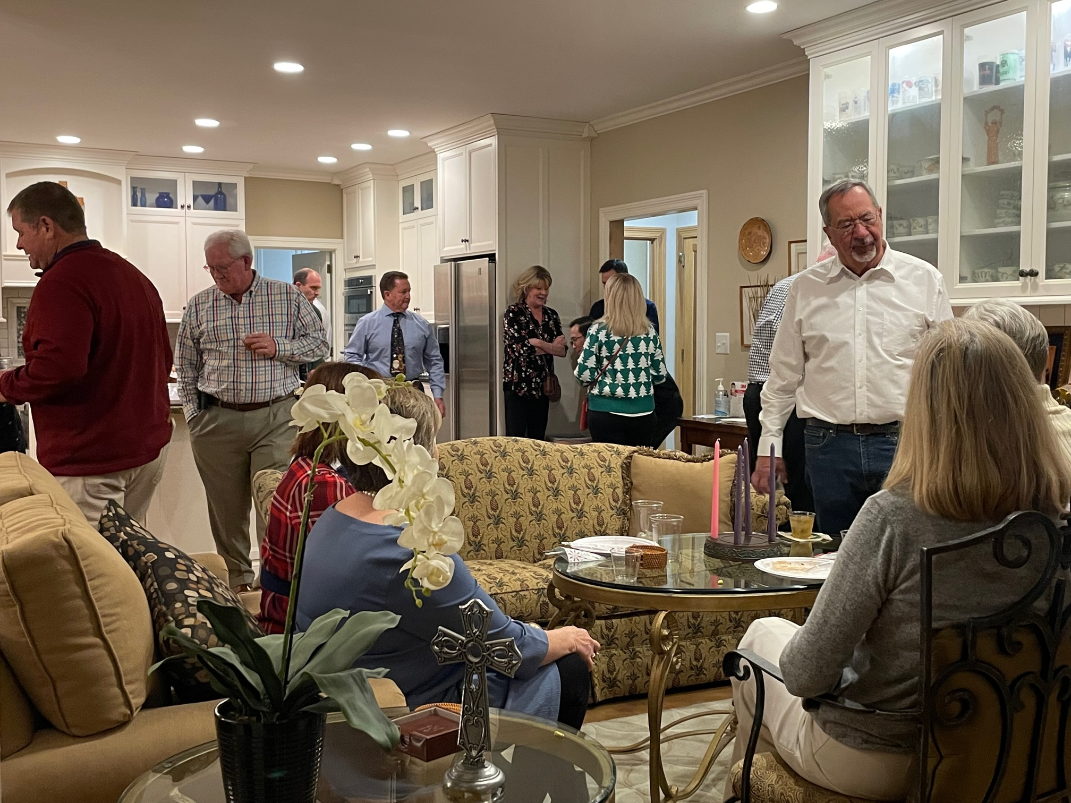  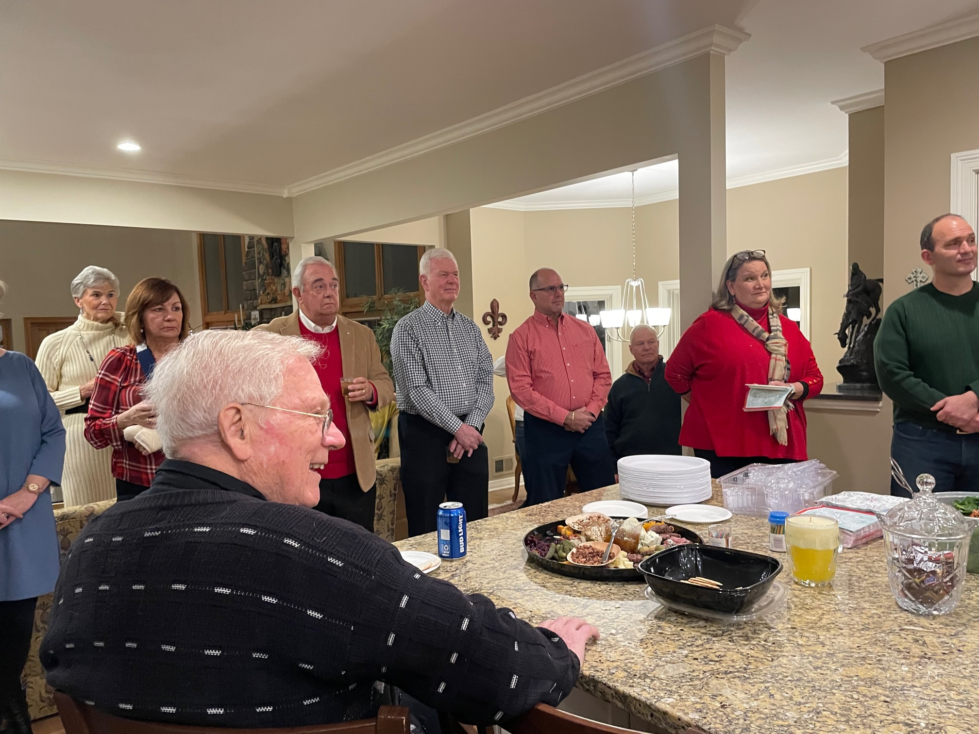  Refugee family welcomed with Christmas cheer  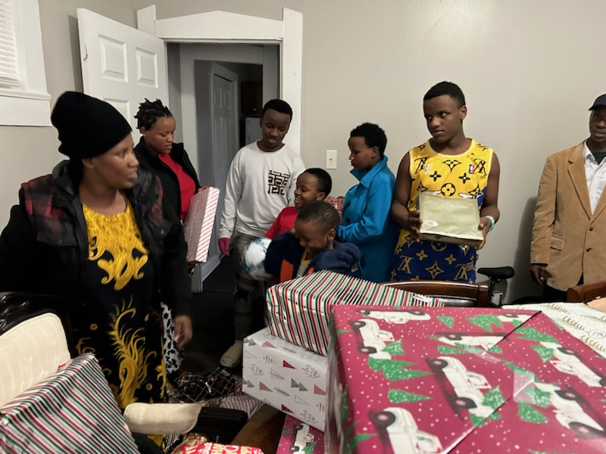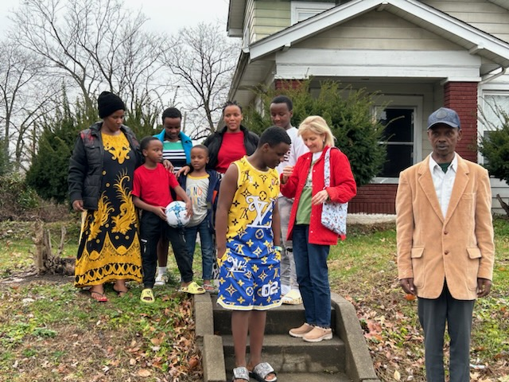  Christmas gifts were dropped to the St Pats refugee family of 8 from the Congo. Butuyenge Dusabe and her husband Lyamuremye Evariste have six children ranging in age from 6 to 19 years.  The Knights donation of $532 bought 2 bikes, shoes, pants and lots of personal hygiene items. They were most appreciative.  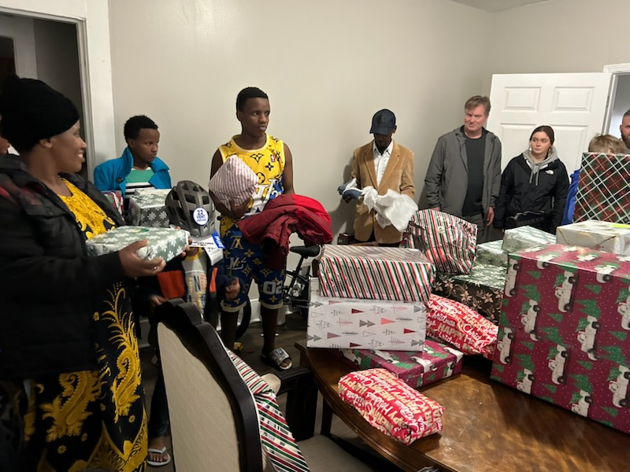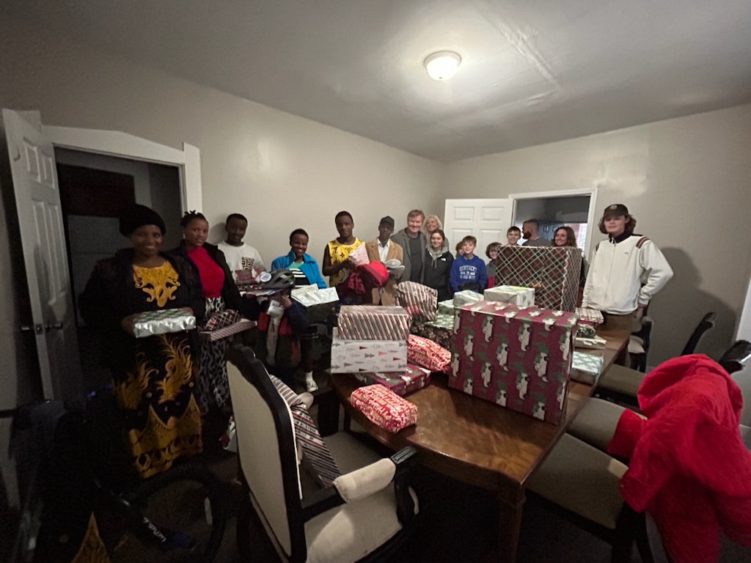  Soup’s on…even in frigid weather!  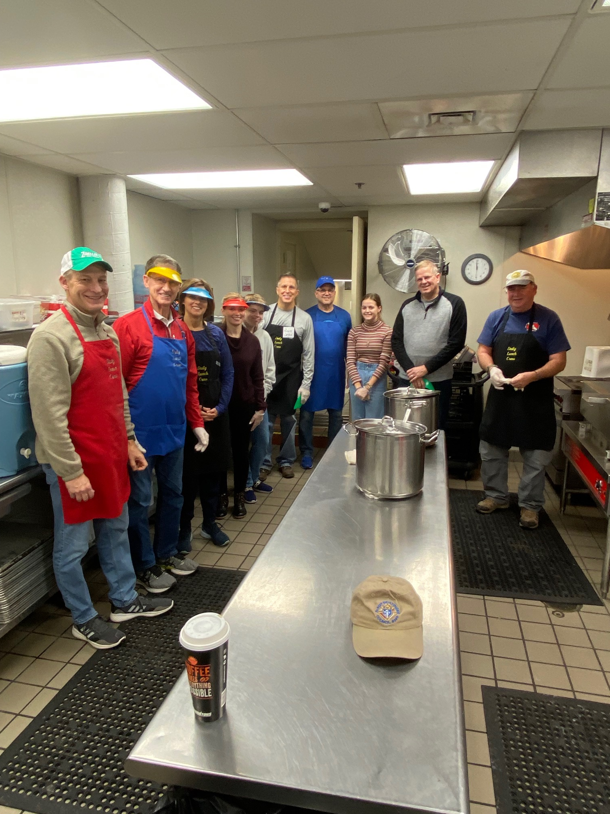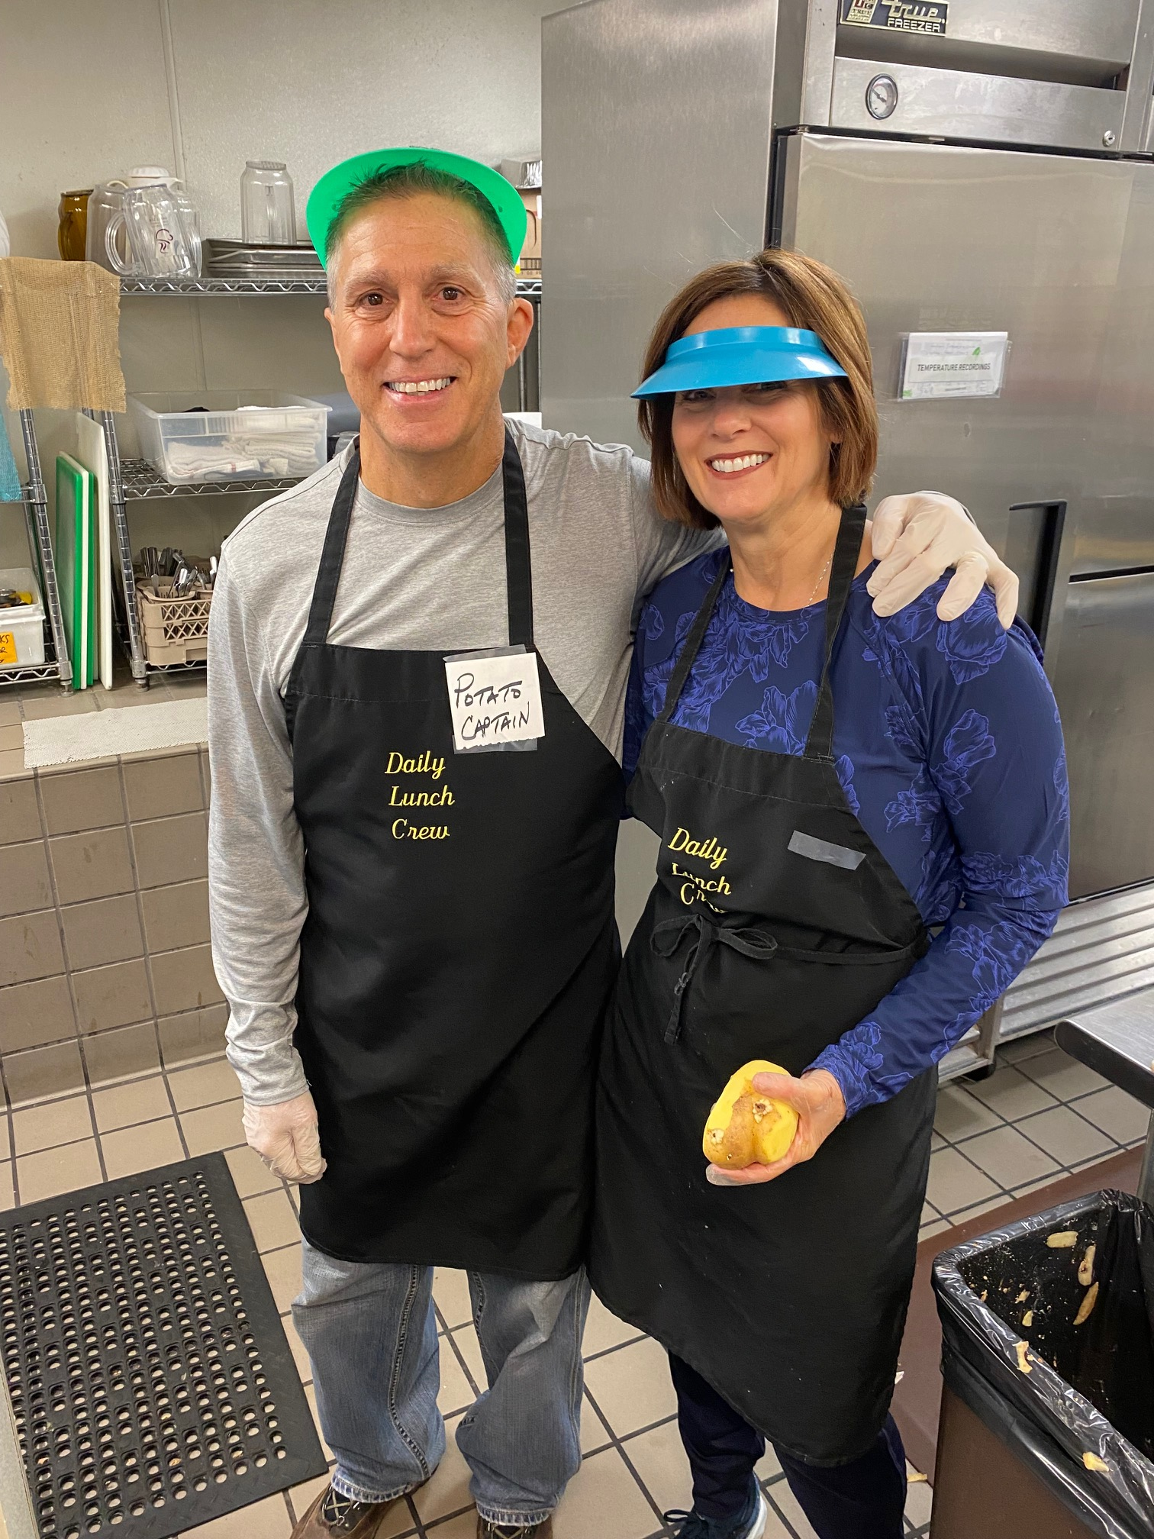  Thanks to the Knights and their families who braved the cold and snowy weather on Christmas Eve to serve the homeless a hot lunch at the Cathedral. Your dedication is appreciated!  Happy January Birthdays!    Birthday wishes go out to the following Brother Knights:  Steve Kiper 2nd  John O'Bryan 11th  Joseph Roche 13th  Larry Jones 17th  Christopher Roszman 19th  Leo Hobbs 26th  Rev. Adam Carrico 27th  John Sarkis 27th  Val Henson 28th

